Ideation Phase
Empathize & Discover

Date | 14 Feb 2026
Team ID | LTVIP2026TMIDS52481
Project Name | Dog Breed Identification using Transfer Learning
Maximum Marks | 4 Marks

Empathy Map Canvas:
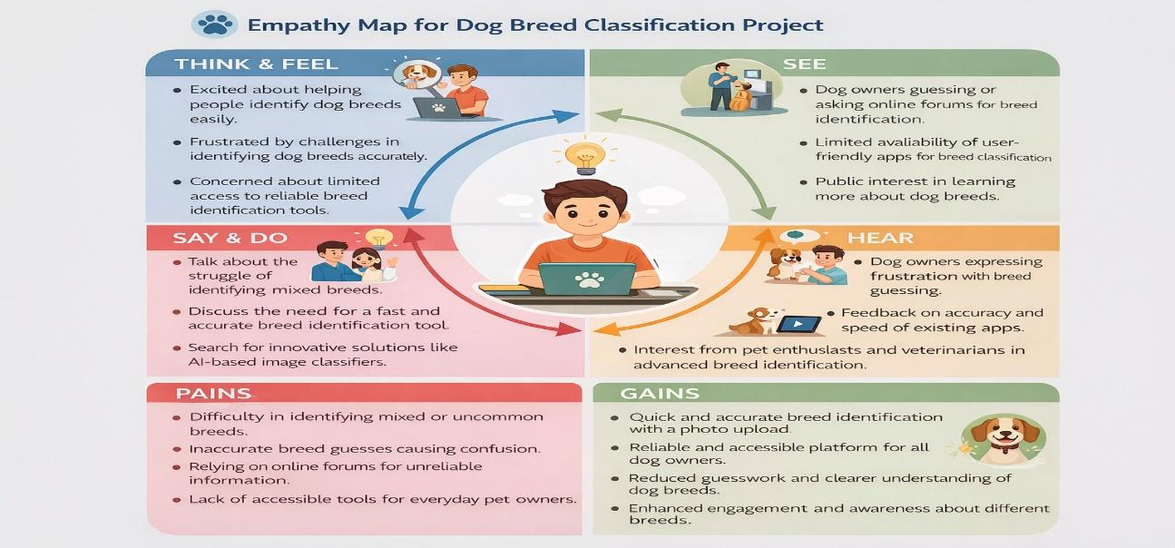

Pains (Problems / Challenges)  1. Difficulty Identifying Dog Breeds  - Many dog breeds look visually similar  - Non-experts cannot correctly recognize breeds from images  2. Manual Verification Dependency  - Requires veterinarians or breed experts  - Time-consuming and inefficient for quick identification  3. Limited Accessibility  - Breed information not easily available everywhere  - Pet owners in remote areas lack expert guidance  4. Human Error  - Misidentification due to lack of knowledge or experience  - Inconsistent results across different observers | Gains (Benefits / Value)  1. Fast Breed Identification  - AI model detects dog breed instantly from an image  - Saves time for pet owners and veterinarians  2. Automated Image-Based Diagnosis  - CNN / Transfer Learning analyzes images automatically  - Reduces dependence on manual breed experts  3. High Prediction Accuracy  - Deep learning captures subtle visual features  - Provides reliable and consistent classification results  4. Scalable & User Friendly  - Can classify thousands of images efficiently  - Useful for mobile apps, veterinary tools, and pet services

